

SUPERIOR UNIVERSITY LAHORE
GOLD CAMPUS

NAME: MUHAMMAD MOIZ RAZA
ROLL NO: SU92-BSAIM-F24-061
PROGRAM: ARTIFICIAL INTELLIGENCE
SEMESTER: 4th SEMESTER
SECTION: BSAI-4A
SUBJECT: PROGRAMMING OF AI (LAB)

Submission Title: LAB TASK 12
Submitted To: Sir Rasikh Ali

TITLE: RESTURANT CHATBOT ADVANCED

Overview
This project is a Restaurant Chatbot built using Flask and AI-based semantic search. It helps users get quick answers about restaurant services such as menu items, prices, delivery, ordering, timing, and reservations. The chatbot works on a web page where users can chat and get instant responses.
The system combines two approaches: a rule-based chatbot (regex patterns) and an AI-based embedding search system (FAISS) to understand user queries more effectively.

Working
When a user sends a message, it is received by the Flask backend through an API. First, the chatbot checks the message using predefined rules (regex patterns). If a match is found, it returns a fixed response like menu details or timing.
If no rule matches, the message is converted into embeddings using a sentence transformer model. Then FAISS compares it with stored embeddings to find the most similar question from the dataset. The best answer is returned and shown to the user on the website.

USES OF CHATBOT
Provides restaurant information quickly
Helps customers check menu and prices
Supports order tracking and reservations
Gives 24/7 automated customer support

Reduces workload of restaurant staff

Advantages
- Fast and real-time responses
- Easy to use web interface
- Combines rule-based + AI system
- Understands meaning using embeddings
- Works without human support
- Improves customer experience

Disadvantages
- Requires internet and server setup
- Complex compared to simple chatbots
- Depends on dataset quality
- Needs updates for new information
- Not fully intelligent like human chat
SCREENSHOT
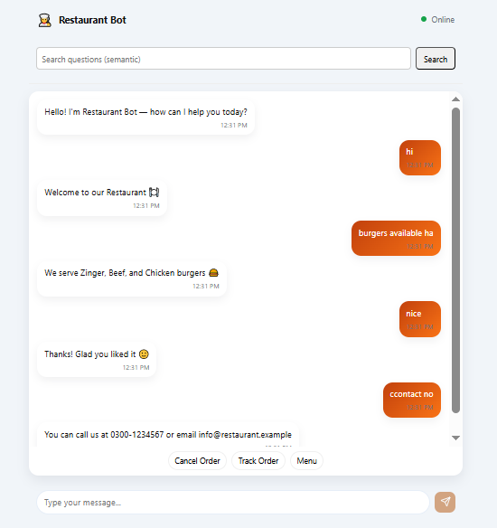

THE END

